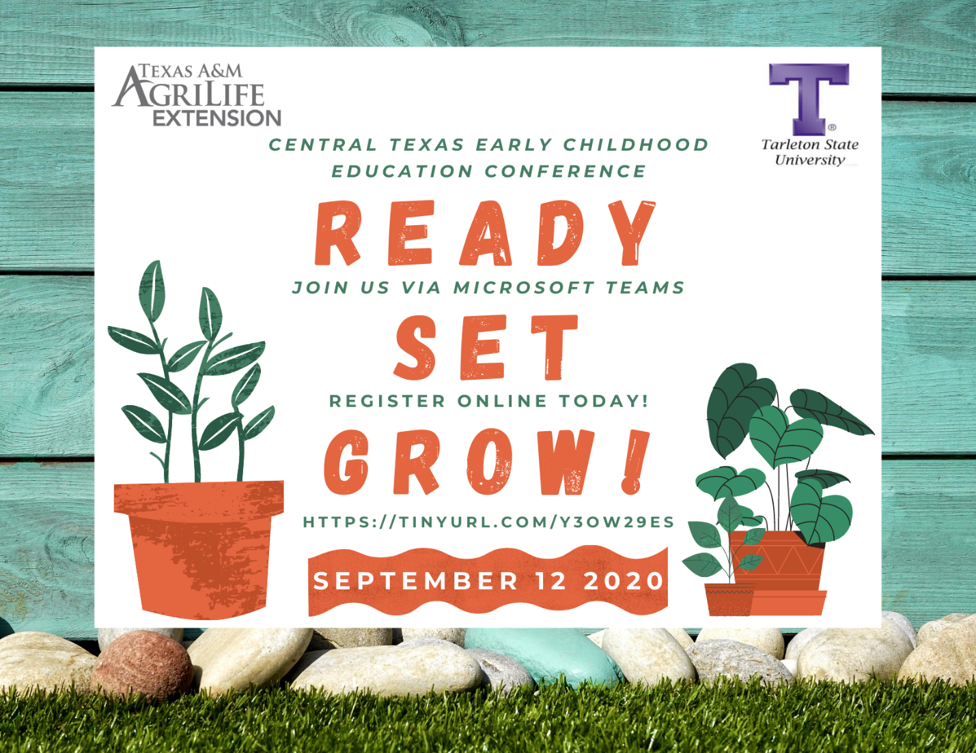

“Texas A&M AgriLife Extension and Tarleton State University are once again thrilled to host our annual Central Texas Early Childhood Education Conference! Join us online this year for live-instructed sessions including relevant topics like Minimum Standards, Creating a Diverse Environment, Abuse & Neglect, and Emotional Management, a total of four clock hours. CEUS are also available.
Register today at https://tinyurl.com/y3ow29es or visit https://johnson.agrilife.org/event/central-texas-early-childhood-education-conference-2020/ for more information.
Are you ready? Set? Let’s grow together at the 2020 CTECEC!”

